Paper Formatting Guidelines

TITLE OF PAPER (LIMITED TO 100 CHARACTERS)

Johan Silas
Department of Architecture, Institute of Technology Sepuluh Nopember,
Indonesia
e-mail: mukimits@yahoo.com

or multiple authors:

Hartatik*, Johan Silas**
*) Master Student, Department of Architecture, Faculty of Civil Engineering and Planning, Institute of Technology Sepuluh Nopember , Indonesia
**)Lecturer, Department of Architecture, Faculty of Civil Engineering and Planning, Institute of Technology Sepuluh Nopember, Indonesia
e-mail: mukimits@yahoo.com

ABSTRACT

Abstract should be written in English and contain a brief, clear statement of background, problems, objectives, theory/ methods and conclusion of the study. The abstract body should be under 300 words limitation and precede the introduction. Text of the abstract should be 11 points, Times New Roman, Italic and justified with single line spacing.

Keywords: abstract should be represented within 3-5 keywords

INTRODUCTION

Kindly use this MS-Word template given. We suggest you to use this document only as your guide (template) and simply copy and paste your text over the material in this document.
All papers (around 8,000 words or about 12 pages) should follow the layout:
- 18.2 x 25.7 cm paper size (B-5 Size)
- Portrait orientation
- Mirror margin
- Top margin: 2.49 cm
- Bottom margin: 2,49 cm
- Inside margin: 3 cm
- Outside margin: 2.01 cm
- Header and Footer: 1.27 cm
- Indents – first paragraph of section is none, the second and later 1,27 cm
- Spacing between paragraphs: none
- Spacing between last paragraph and new section: 2 Single space
- Spacing between section and sub-section: Single space

paper title and author data

Paper Title

This information should be placed at the top of the first page in 14 point, Times New Roman in capital with left alignment text. Title of the paper should be written in capital but not in bold, e.g. TITLE OF THE PAPER

Author Listing

12 point, Times New Roman, left alignment text. Use the full name for author(s), e.g. Johan Silas.

Author Affiliations

11 point, Times New Roman, left alignment text and under the author’s name. Each author should write his/her affiliation. Information such as department of college, university, city, state and country can be listed. If you list the e-mail address make sure the Hyperlink is not attached. For multiple authors, list the author names under the title and give marks (*/**/***) beside name to distinguish the affiliation.
The affiliations should be written in the same order following the authors appear in the author listing. For multiple authors, use only the e-mail of the first author. No footnote is needed.

paper BODY FORMAT

Section Title

Section title should not be numbered, Capital, Bold, 12 point, Times New Roman and left justified. Sub-section title should be Bold, Title Case, 11 point, Times New Roman and left justified.

Text of the Paragraph

Text of the paragraph should be 11 points, Times New Roman and justified with single line spacing. The writer should use numbering instead of bullets.
- Numbering: 11 point, Times New Roman and justified with single line spacing. Indent the text 0.5 cm. Use Roman numerals. Insert a single space after the numbering list (before new paragraph).
- Multilevel list: 11 point, Font Times New Roman and justified with single line spacing. Indent the text 0.5 cm. Use alphabetic order.
- All numbering and multilevel list should follow the example in this document.
- Give single space after each paragraph.
- Give 2 single space after the end of final paragraph in each section
- There is no need to give space after the end of final paragraph in each section if the paragraph reaches the end of the paper format.

The manuscript should be between 12 to 25 pages. The body of the paper should include:
- Introduction to the subject
- Theory / research methods
- Results and discussion: can be written in many different topics
- Conclusions
- References

Source

Source should contain the reference by giving the last name of the author(s) followed by the year of publication in parentheses, e.g. (Silas, 2010). Endnotes and footnotes are not permitted and should be avoided at all possible. All of the relevant information apart from references should be incorporated into the main text.

FIGURES AND TABLES

Do not abbreviate ‘Table’ and ‘Figure’. Use Roman numerals to number tables and figures. Refer to all tables as Table. Refer to all illustrations (maps, diagrams, charts, photographs, etc.) as Figure.
Use the following format guidelines for Figures and Tables:
- Figure and Table captions: 10 point, Times New Roman, Upper Case title, and centred.The writing‘Table 1.’ and ‘Figure 1.’should be bold. The heading should be under a Figure and above for a Table. Leave single space above and below each Figure. Leave single space above each Table.
- Table headings: 10 point, Times New Roman, Upper Case title and centred.
- Table text: 10 point, Times New Roman.
- Source: 8 point, Times New Roman. For a Figure, source should follow the caption. For a Table, source should be placed under the Table, centred. Source should contain the reference by giving the last name of the author(s) followed by the year of publication.
- Note: 8 point, Times New Roman. For a Table, note should be written under source, centred.
Table 1. The Condition of Tempe Lake on the Rainy and Dry Season

No | Season | Month | Height of water level | Wide of water level  (acre)
1  2  3 | Rainy season  Dry season  Severe drought year | May-August  June-Dec | Elevation 7.0-9.0 m  Elevation 4.5 m  Elevation 3.5 m | 28.000-43.000  10.000  1.000
Source: Naidah, 2010
Note: The elevation of Tempe Lake is Elevated 3.00 meter on the lowest point.

The manuscript’s graphics should have resolutions of 600 dpi for mono chrome, 300 dpi for greyscale, and 300 dpi for colour.

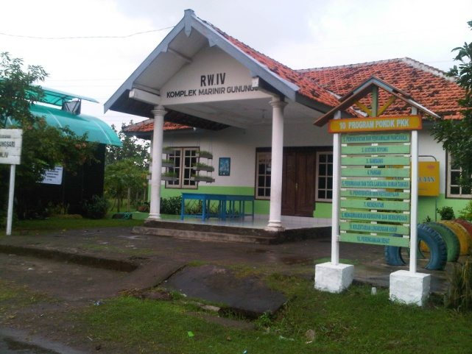

Figure 1. Community Center in the Kampung,
Surabaya
Source: field survey, 2012

HEADERS AND FOOTERS

Please use the following format guidelines for Header and Footer.
- Header text: Please use this document as your guide.
- No footer is needed

ACKNOWLEDGMENT

Writers are allowed to write an acknowledgment chapter in the end of the paper. The acknowledgment is placed after the final section but before the reference.

references

Place the references in a separate section at the end of the document as indicated in this format. Do not footnote references. Do not put figures or anything else after the references.
Reference text: 11 point, Times New Roman, justified. Indents 1 cm. Please use the following format guidelines for reference writing. Reference should be written in its original language.

Books:
Author’s last name, initial. (year), Titleof the Book, Name of the publisher, Location of the publisher.
Books with multiple authors:
1st Author’s last name, initial. and 2nd Author’s last name, initial. (year), Title of the Book, Name of the publisher, Location of the publisher.
Editorial Books:
Author’s last name, initial. (year), Title of Article, Initial name of the editors [eds], Title of the Editorial Books, Name of the publisher, Location of the publisher.
Journal:
Author’s last name, initial. (year), Title of Article, Name of the Journal, Volume (Number), pages, Name of the Journal Publisher, Location of the Journal Publisher.
Paper for Conference and Symposium Proceeding:
Author’s last name, initial. (year), Title of Paper, Paper/Proceeding for Title of the Conference, pages, Date of the Conference, Location of the Conference.
Report:
Author’s last name, initial. (year), Titleof the Report (Annual report/version of the report), Name of the publisher, Location of the publisher.
Thesis/Dissertation:
Author’s last name, initial. (year), Title of the Disertacion, Unpublished Thesis/ Dissertation, Name of the publisher/university, Location of the publisher/ university.
Download:
Author’s last name, initial. (year), Title of the Article, <web address> (Accessed on Date).

Example

BBC Brasil (2006), Brasil terá 55 milhões vivendo em favelas até 2020, diz ONU. Folha de São Paulo, <http://www1.folha.uol.com.br/folha/bbc/ ult272u5415 5.shtml> (Accessed on 16 June 2006).
CONAVI / Centro Jacinto Lara. (2005), Plan Sectorial de Zonas de Barrios. Barquisimeto-Cabudare Volume 7 (Annual Report), Ministerio de Vivienda y Hábitat, Caracas, Venezuela (In Spanish).
Habraken, N. J. (1976), The Limits of Professionalism, Architectural Association Quarterly, 8(1), 52-59, Pergamon Press, London.
Hamdi, N. (1995), Housing without houses, Intermediate Technology Publications Ltd., London.
Hamnett, C. and Williams, P.(1979),Gentrification in London 1961-71:an Empirical and Theory Analysis of Social Change, University of Birmingham Centre for Urban a Regional Studies, Birmingham.
Haryadi (1989), Residents’ Strategies for Coping with Environmental Press: Relation to House-settlement System in a Yogyakarta Kampung, Indonesia, Unpublished Dissertation, Department of Architecture, The University of Wisconsin, Milwaukee.
Silas, J. (1983), Spatial Structure, Housing Delivery, Land Tenure and the Urban Poor in Surabaya, Indonesia, in Angel, S. [ed], Land for Housing the Poor, Select Books, Bangkok.

